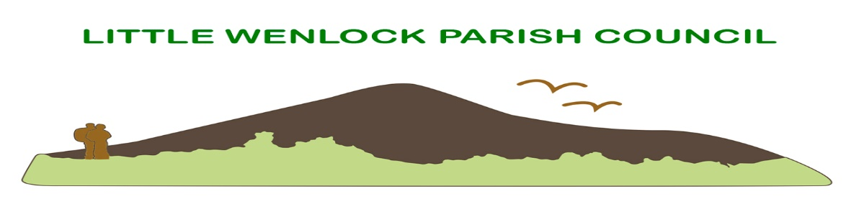
Clerk: Mrs Jayne Madeley BA 01746 785175 email: clerk@littlewenlock-pc.co.uk.
Website www.littlewenlock-pc.co.uk

Agenda of the meeting of Little Wenlock Parish Council’s Finance Committee to be held on Monday 11th July 2022 in the Village Hall Malthouse Bank Little Wenlock at 6pm

- Public Session.
- Record members present.
- Receive apologies and reasons for absence.
- Dispensations and declaration of personal or prejudicial interests.
- To consider the budget for the current financial year.
7. Date of next scheduled meeting 12th September 2022 of Parish Council.

