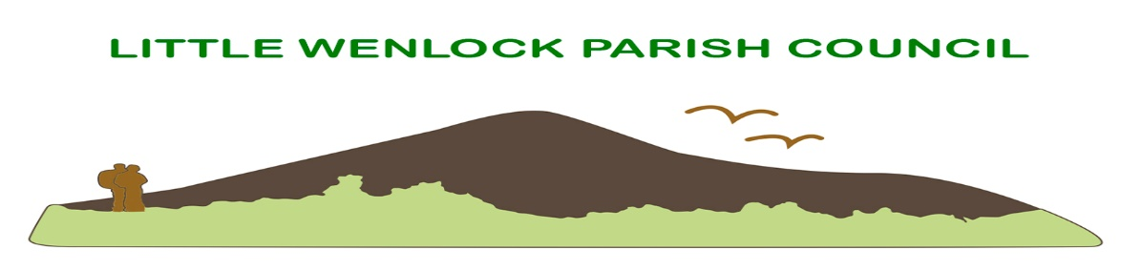
Clerk: Mrs Jayne Madeley BA 01746 785175 email: clerk@littlewenlock-pc.co.uk.
Website www.littlewenlock-pc.co.uk

Agenda of the meeting of Little Wenlock Parish Council to be held on Monday 11th July 2022 in the Village Hall Malthouse Bank Little Wenlock at to follow Finance committee meeting.

- Public Session.
- Record members present.
- Receive apologies and reasons for absence.
- Dispensations and declaration of personal or prejudicial interests.
5. Minutes of the meeting held on 13th June and 27th June 2022.
6. Borough of Telford and Wrekin Liaison.
7. Finance.
a. Consider payment of invoices.
1. SSE street lighting.
2. Mrs J E Madeley £ 617.60Chq 53 July
3. HMRC £3.20 Chq 54
4. Shropshire Council Pension (online payment) £197.08 OLP
5. Telford and Wrekin Council £119.97 chq 55
7. Mrs J Madeley Expenses £ Chq 56
8. Mrs R Turner £135.00 chq 57
9. Leafield Environmental Ltd £844.80 OLP
10. E. on £192.00 Chq 58
11. ICO £35.00 dd.
12. Ak Williams Debit card £30.00
13. Mrs J Madeley £617.40 Chq 59 August
14. HMRC £3.40 Chq 60 August
15. Shropshire Council Pension. £197.08 OLP
16. ROSPA £159.60 Chq 61
b. Bank Reconciliation.
c. Bank Mandate update.
d. Consider grant request from St Lawrence PCC for funds towards church bell changes.
e. Consider quote to conduct repairs on play equipment.
f. Internal Audit report action plan.
g. Approve budget for financial year ended 31.3.22.
8. Parking at the foot of The Wrekin.
a. update.
9. Approve new standing orders to include a slight amendment.
10. Approve Complaints Procedure.
11. Playing field and village hall committee and Parish Council agreement.
12. Planning:
a. New Applications:
b. Decisions:
- TWC/2022/0302 Erection of a single storey detached garage and workshop following demolition of existing triple garage. The Old Rectory Church Lane Little Wenlock. Full Planning Permission.
- TWC/2022/0389 Erection of one two storey detached holiday let. Land adjacent 39 Coalmoor Lane Little Wenlock. Full planning permission.
c. Planning Inspectorate appeal New Works Lane Solar Farm APP/C3240/W/22/3293667.
d. DMMO/2019/0001 Determination Decision. Upgrade footpath 67 and 72 to a bridleway over The Wrekin and addition of footpath 75.
e. Local Development Scheme Telford and Wrekin 2022-2025
13. Community Safety
a. SID
i. data
ii. Consider running device with no flashing speed but collect data for a comparison.
b. Consider asking Telford and Wrekin to install a mirror to help safe use of the Malthouse Bank junction to Huntington. Update.
c. Consider moving bin from junction of Highpoint and The Alley to the bus shelter. Update.
d. Consider New Works traffic regulation order.
e. Recycling bin update.
f. New Works Light replacement.
g. Police and Crime Commissioner Town and Parish Council survey.
h. ROSPA safety report.
i. Trundle signage.
14. Clerk’s Report.
15. Individual Councillors Report and updates:
a. Update from Rights of Way Telford and Wrekin.
b. Village Hall and playing fields committee.
c. recycling bin.
16. Correspondence:
a. Climate Care Course
b. letter from Donnington and Muxton Parish Council regarding bus users’ group.
c. email from resident regarding speeding traffic.
d. email from resident suggesting e group for circulating minutes.
17. Date of next schedule meeting.
Next scheduled meeting is 12th September 2022.
18. Confidential matters. Resolution to exclude public and press in accordance with LGA 1972 SS100 and 102 and Public Bodies (Admission to Meetings) Act 1960.

