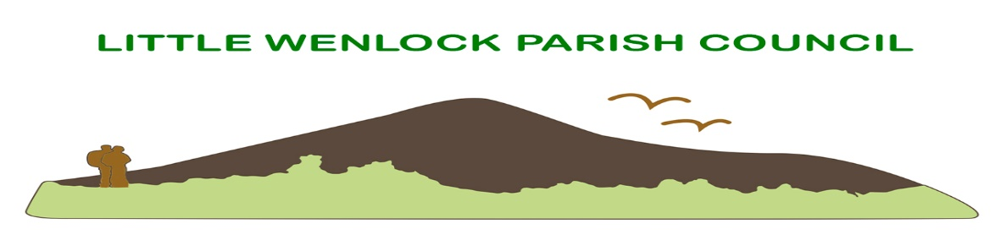
Clerk: Mrs Jayne Madeley BA 01746 785175 email: clerk@littlewenlock-pc.co.uk.
Website www.littlewenlock-pc.co.uk

Agenda of the meeting of Little Wenlock Parish Council to be held on Monday 13th June 2022 in the Village Hall Malthouse Bank Little Wenlock at 7.30pm

- Public Session.
- Record members present.
- Receive apologies and reasons for absence.
- Dispensations and declaration of personal or prejudicial interests.
- Election of.
a. Vice Chair.
b. Wrekin Forest Partnership.
c. Wrekin Rural Parish Forum.
d. Shropshire Association of Local Councils. Wrekin Area Committee.
e. Local Access Forum.
f. Snow Liaison volunteer.
6. Minutes of the meeting held on 9th May and 11th April 2022.
7. Borough of Telford and Wrekin Liaison.
8. Finance.
a. Consider payment of invoices.
1. SSE street lighting May £29.03, £16.92 and £9.82.
2. Mrs J E Madeley £ 617.40Chq 46
3. HMRC £3.40 Chq 47
4. Shropshire Council Pension (online payment) £197.08 OLP
5. K & P Smith £600.00 Chq 48
6. Mrs J Madeley £326.16 mug 49
7. Mrs J Madeley Expenses £ Chq 50
8. St Lawrence PCC £500.00 Chq 51
9. Leafield Environmental Ltd £844.80 OLP
b. Bank Reconciliation.
c. Bank Mandate update.
d. confirmation of new contract SSE.
e. Finance Committee date of meeting.

9. Annual Audit:
a. Consider approving completion of the certificate of exemption of external audit.
b. Approve internal audit.
c. Approve annual governance statement.
d. Approve annual accounts statement.
10. Parking at the foot of The Wrekin.
a. update.
b. update on Forest Glen pay for parking scheme Shropshire Wildlife Trust
11. Consider discussion with Church to enable a ceremony for remembrance Sunday.
12. Consider the future of Delegated powers given to ensure the work of the parish council can continue during the pandemic.
13. Playing field and village hall committee and Parish Council agreement.
14. Planning:
a. New Applications:
- TWC/2022/0036 Site of Hollydale & Stretton View Buildwas Road Ironbridge. Amended certificate of Ownership received.
- TWC/2022/0389 Land adjacent 39 Coalmoor Lane Little Wenlock. Erection of 1 two storey holiday let.
b. Decisions:
- TWC/2022/0344 Fair acre Buildwas Lane Little Wenlock. Erection of a single storey front and side extension. Grant Full Planning Permission.
c. Planning Inspectorate appeal New Works Lane Solar Farm APP/C3240/W/22/3293667. Confirmation the Secretary of State for Levelling up, Housing and Communities has recovered the application. This means he will make the decision based on the inspector’s report.
15. Community Safety
a. SID
i. data
ii. battery (no warranty.) quote for a new one.
b. Consider asking Telford and Wrekin to install a mirror to help safe use of the Malthouse Bank junction to Huntington.
c. Consider moving bin from junction of Highpoint and The Alley to the bus shelter. (See report).
d. Consider seeking legal advice regarding the lease for the Little Wenlock Bus Shelter.
16. Clerk’s Report.
17. Individual Councillors Report and updates:
a. Update from Rights of Way Telford and Wrekin.
b. Village Hall and playing fields committee.
c. recycling bin.
18. Jubilee. A report of the mug distribution, beating bounds and tea party.
19. Correspondence:
a. Neighbourhood matters. West Mercia police.
b. Telford and Wrekin Climate Action Investment.
c. CPRE Shropshire AGM notice and annual report.
20. Date of next schedule meeting to be confirmed.
Next scheduled meeting is 11th July 2022.

12. Delegation wording.
To note that it is lawful for the clerk to spend against specific items in the Parish Council’s budget i.e., for contractors, hall hire, clerk’s salary, all of which having been identified in the budget when setting the precept, any such payments to be reported to the Council at the next ordinary meeting.

• To approve provision of delegated powers to your Clerk to spend up to a limited amount £10000.00 and to authorise urgent work when unforeseen circumstances occur.
• Delegated powers to the Clerk to respond to planning applications (councillors are still able to submit their own personal comments) after consultation via email with councillors.
• Agreement to delegate the postponement of meetings of the Council on the (should this be required)
- Agreement to receive and act upon Government advice in relation to the holding of the Annual Meeting of the Parish scheduled to meeting (noting such meetings must be held before 1 June) and the Annual Meeting of the Parish Council scheduled to meet in May (noting such a meeting must be held in May), thereby giving delegated power to the Clerk to make necessary re-arrangements for these meetings in consultation with the Chair.

The delegation during covid was used to allow the work of the parish council to continue.

Delegation in Financial regulations is included in point 4 of the regulations.

15c. Litter bin
A resident has asked Telford and Wrekin if the bin by the post box can be moved to the bus shelter. The bus shelter belongs to the parish council. I was uncertain about ownership of the land it sits on. I have now found in an interesting bag of papers a lease from 1969 between the pc and the then owner of “Wrekin View”. It is a rolling lease for a £1. No money has changed hands in my time as clerk.
Telford and Wrekin have asked if the parish council will give permission for the bin to be moved. The bin belongs to Telford and Wrekin.
The Lease clearly says no other structure should be installed. But the next clause states the site should be kept clear of rubbish and later make arrangements for the removal of.

16. Clerk’s Report
- Litter bin installed at end of Coalmoor Lane.
- The invoice to telford and Wrekin for £162.00 has been cancelled.
- Clerk attended a briefing about the Queens Award for voluntary service. With the village hall committee in mind.

