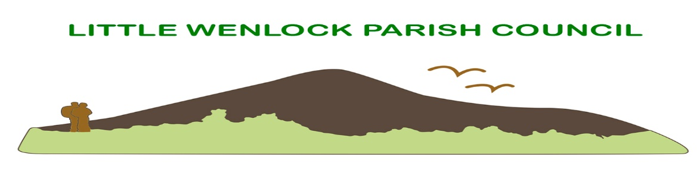
Clerk: Mrs Jayne Madeley BA 01746 785175 email: clerk@littlewenlock-pc.co.uk.
Website www.littlewenlock-pc.co.uk

Agenda of the Annual meeting of Little Wenlock Parish Council to be held on Monday 9th 2022 in the Village Hall Malthouse Bank Little Wenlock

- Election of Chair.
- Public Session.
- Record members present.
- Receive apologies and reasons for absence.
- Dispensations and declaration of personal or prejudicial interests.
- Election of.
a. Vice Chair.
b. Little Wenlock Village Hall and Playing Field Committee.
c. Wrekin Forest Partnership.
d. Wrekin Rural Parish Forum.
e. Shropshire Association of Local Councils.
f. Local Access Forum.
g. Snow Liaison volunteer.
7. Allocation of Consultation Responsibilities:
  - Highways and Public transport.
  - Snow Warden and winter gritting.
  - Litter Picking.
  - Rights of Way.
  - Dogs.
- Annual Review of Risk Assessment and policies:
- Assets Register
- Standing orders, financial regulations, and financial risk assessment.
C. All other policies listed in report.
D. Consider the delegated powers the clerk holds to enable the business of the Council to continue if needed.
9. Minutes of the meeting held on 11TH April 2022.
10. Borough of Telford and Wrekin Liaison.

11. Finance.
a. Consider payment of invoices.
1. SSE street lighting to be confirmed at meetings.
2. Mrs J E Madeley £617.40 Chq 42
3. HMRC £3.40 Chq 43
4. Shropshire Council Pension (online payment) £197.08
5. AGE UK olp £250.00
6. TWC £162.00 Chq 44
7. Mrs J Madeley Expenses £84.75 Chq 45
8. SALC £268.17 Chq 46
9. Leafield Environmental Ltd £844.80 OLP
10. AK Williams & Sons Ltd £168.00
11. Everything Branded UK. tbc
12. Bridgnorth Print cd pmt £61.50
b. Bank Reconciliation.
c. Consider grant to St Lawrence PCC for grounds maintenance.
d. Bank Mandate update.
12. Annual Audit:
A. update.
13. Parking at the foot of The Wrekin.
a. update.
14. Planning:
a. New Applications:
- TWC/2022/0344 Fair acre Buildwas Lane Little Wenlock. Erection of a single storey front and side extension.
b. Decisions:
- TWC/2021/1071 Installation of a ground mounted solar farm with continued agricultural use (grazing) ancillary infrastructure and security fencing, landscape provision
15. Community Safety
a. Confirmation the Playsafety ROSPA inspection will be conducted shortly.
b. SID progress.
c. Consider working with Lawley and Overdale Parish Council and Telford and Wrekin Council regarding respecting the countryside flora and fauna.
17. Clerk’s Report.
18. Individual Councillors Report and updates:
a. Update from Rights of Way Telford and Wrekin.
b. Village Hall and playing fields committee.
c. Consider an event beating the bounds of the Parish.
d. recycling bin.
19. Jubilee
20. Correspondence:
a. Letter from resident regarding Steeraway Farm Solar farm.
b. Celebrating Carers event 7th June TWC
c. CPRE The Voices newsletter.
21. Date of next schedule meeting to be confirmed.
Next scheduled meeting is 13th June 2022.

8c. List of Policies
- Vexatious Procedure
- Social Media
- Planning policy
- Media policy
- Publication Scheme
- Co-option policy
- Managing pre application planning consultations.
- Grant awarding policy
- Communications.
- Guidance for members of the public attending meetings.
All available on website.

Delegation wording.
8D. To note that it is lawful for the clerk to spend against specific items in the Parish Council’s budget i.e., for contractors, hall hire, clerk’s salary, all of which having been identified in the budget when setting the precept, any such payments to be reported to the Council at the next ordinary meeting.
17. Clerk’s Report
- Library cupboard for New Works ordered and collected.
- Telford and Wrekin working with parish and town councils’ charter. Do you want to sign this?
- Clerk has booked a QAVS briefing session.
- Re Read agreement with village hall and playing field committee regarding works. No action.

Actions for next meetings.
- Cloud Share.
- Mirror on Malthouse Bank Junction to Huntington to enable vision of vehicles travelling from Coalmoor.
- Refreshed remembrance service.
- Finance committee meeting to discuss budget.

