Clerk: Mrs Jayne Madeley BA 01746 785175 email: clerk@littlewenlock-pc.co.uk.
Website www.littlewenlock-pc.co.uk

You are hereby invited to the Meeting of the Parish Council on
Monday 13th September 2021 in the village hall large hall at 7.30 pm.

Members of the public are welcome to attend the meeting. To find out how please contact the clerk via email. clerk@littlewenlock-pc.co.uk.

1. Public Session.
2. Record members present.
3. Receive apologies and reasons for absence.
4. Dispensations and declaration of personal or prejudicial interests.
5. Minutes of the meeting held on 19th July 2021 and 16th August 2021.
6. Borough of Telford and Wrekin Liaison.
7. Finance.
a. Consider payment of invoices.
1. SSE street lighting August £16.92, £29.03 and £9.82
2. Mrs J E Madeley Sep Salary £578.35
3. HMRC PAYE Sep £31.80
4. Shropshire Council Pension (online payment) £193.69
5. Mrs J Madeley Expenses £49.50
6. ROSPA Play Safety £157.80
7. K Smith Contracting Services £1194.00
b. Bank Reconciliation. Jul and Aug 21
c. New Bank Account. Update.
d. Boiler change at Village Hall Grant.
f. contract for grounds maintenance.
g. Borough Councillor Pride Fund.
h. Electricity rates
i. Internal Audit recommendations
j. Clerk’s underpayment of salary.
k. Consider obtaining a valuation for War Memorial.
8. Consider Grant applications received.
1. Hope house.
2. Telford and Wrekin rights of Way £1000.00.
3. Age UK
9. Parking at the foot of The Wrekin. a. Update.
10. Consider proposal. from Councillor Marcham That The new Wellington and Newport constituency remains named The Wrekin.
11. Consider setting up a community book share in each bus shelter. Councillor Stevens.
12. Planning:
a. New Applications:
b. Decisions:
- TWC/2021/0577 Erection of 1 single storey detached holiday let. Land adjacent 39 Coalmoor Lane Little Wenlock. Full Planning Permission.
- TWC/2021/0620 Erection of 1 garden log cabin. 4 Clee Rise Little Wenlock.
Full planning permission.
c. Notice of Modification order Upgrade of footpath 18 to Bridleway (Wrekin Hill).
d. Steeraway solar farm public consultation events a report.
e. Any other planning matters: Query re possible planning enforcement matter.
13. Community Safety
a. SID. a. update
b. consider purchasing solar panel technology.
b. New Works Strimming.
c. ROSPA playing field safety report. Some minor works to be carried out.
d. Traffic calming scheme.
e. Consider a defibrillator training event.
14. Clerk’s Report.
15. Individual Councillors Report and updates:
a. Update from Rights of Way.
b. Village Hall and playing fields committee.
c. Wrekin Forest Partnership
16. Consider adopting an expenses for employees policy
17. Consider a written planning policy.
18. Correspondence:
a. CPRE Fieldwork and Countryside Voices and summer newsletter
b. Veolia Community enviro grant scheme.
c. Thankyou email from St Lawrence PCC.
d. Telford Samaritans AGM 27th September 2021.
e. Correspondence from a resident regarding New Works Solar Farm.
f. West Mercia Police 3 key priorities from the Parish.
15. Date of next schedule meeting to be confirmed.
Next scheduled meeting is 11th October 2021.

Report

7. Internal Audit Report.

Recommendations

- Put in place contract for grounds maintenance contractor and review it periodically, to include considering the need to seek alternative quotes. October Agenda
- Specific numerical details of the budget and precept set should be included within the minutes for clarity and transparency. Now done.
- Review reserves and consider whether to transfer some of the unearmarked reserves into earmarked reserves. See accounts
- Check amount of VAT claimed against cashbook and rectify with HMRC on the next claim if there is a discrepancy.
- Ensure the full list of required info is published. Done.
- Ensure notice for exercise of public rights is published online. Done.
- Consider getting a valuation of the war memorial and insuring it. September agenda.
- Check salary and pension payments. Clerk has been paying herself 4x hours and rate. Instead of working out the weekly rate multiplying by 52 and dividing by 12. A loss of 4 week a year salary.
September Agenda.

8. Grants
A grant policy was adopted earlier this calendar year. The policy states grant applications will be considered in May annually. It was resolved to defer until September. The grants budget is £500.00. A grant towards the rights of way application could be made from reserves using the power quoted in this report later. There is a budget of £500.00 for Rights of Way that can be used.

- Parking Around The Wrekin.
Temporary signage was installed to identify the Ercall Lane Car Park. More permanent signage will be installed.

13d. Traffic Calming
SID Locations
Wellington Road is now in place but happy to look at other locations if required and you have any funding. (a review of sites was done earlier this year and there are no other sites with verges wide enough within the speed limit areas).
Signs
Replace damaged/worn speed limit signs.
- 30 mph on Church Hill and entering the village from Little Wenlock direction.
- Deer warning signs around New Works (we can speak further on this)
- Should any further signs be identified, these can be addressed also

Vegetation
To be cut back as appropriate to improve sign visibility. One in particular on the approach to Little Wenlock on Malthouse Bank.

Speed Limit Alterations
Little Wenlock
- As previously discussed, the speeds are too high to reduce without further traffic calming measures. As this has not been supported locally, we are unable to reduce the limit to 20mph.

New Works
- Likewise, the speeds are too high to reduce to 20mph but would support moving the 30mph signs to reduce the area of national speed limit. This would be on Church Hill and New Works Lane. This as with all speed changes will be subject to a consultation which I am asking our TRO officer to arrange.

Quiet Lanes
The request for quiet lane status from Little Wenlock through Huntington is problematic due to the speed and road layout. This is a derestricted road (60mph), very straight and narrow with excellent visibility. As a result, does not encourage speeds appropriate for quiet lane status without traffic calming measures which again would not be appropriate in such a location. As a result, we are not able to proceed with this option.

14. Clerk’s Report
1.Rights of way.
Having looked up working on footpaths and bridleways in the bible of all things Parish Council (Local Council Administration12th edition) it is not straight forward.
Repair and maintenance
31.27 A local council may repair and maintain footpaths, bridleways, or restricted byways in its area (but not footways), and the highway authority or principal council may contribute to the cost, but this does not relieve any other authority or person whose duty it may be to repair them. Unless there is an agreement or condition to the contrary, the landowner is bound to keep gates and stiles safe and to the standard or repair necessary to prevent unreasonable interference with users but may claim a quarter of their expenses from the highway authority. If they fail in their duty, the latter may do the work at their expense after 14 days’ notice.
The Council must not carry out works on a walkway or do or place anything in it without the consent of the owner of the of the building unless such consent has already been given in the walkway agreement.
Improvement
31.28 Except where rights of way have been acquired on trust or created under a dedication agreement (see 31.1 above) a power to repair and maintain does not include a power to improve, but reasonable expenditure designed to reduce maintenance costs in the future is not, in this sense, improvement, nor is expenditure upon an improvement (such as drainage) if the public right would become inoperative without it. The “free resource” or the general power of competence or the power to promote wellbeing see 22D-Fabove) could be user to finance improvements.
31.1 says Sometimes there are elongated strips of land owned by a public authority and dedicated or held in trust for public use as roads or footpaths. This, however, is a surprisingly rare situation. Much more commonly the land is private, but various kinds of rights of way subsist across it. These are of two basic types: (1) private rights of way; and (2) highways or public rights of way.
22 D-F is about how funds can be spent.
Footway is a pavement.
Power to promote wellbeing is a Welsh only power.
Free resource is section 137 spending.
Clerk has spoken to SALC, and works cannot be carried out without the consent of Telford and Wrekin rights of way.

2. Clerk has chased the finalising of the legal work surrounding the Playing field.
3. Community Recycling bins. Clerk has contacted Telford and Wrekin the contractor is proposing a trail scheme in some of the busier parts of the Borough.
4. Clerk has explained why minutes are written as they are.
Parish Council minutes are not a verbatim record of a meeting. To add to this General data protection regulations, prevent the publication of residents’ details unless specific consent is given. The minutes merely list the decisions made. If a public session is held merely a list of what was asked.
1 LGA 1972 Sch 12 para 41 (1) says
“Minutes of proceedings of a local council and of its committee must be kept.1 They must record the councillor who were present at the meeting. They are intended to be formal records of official acts and decisions. Minutes should, therefore, not be verbatim report nor be a record of discussions or argument made by councillors. Short simple minutes are to be preferred.
Draft minutes should be circulated to councillors as soon as possible after the meetings to which they relate. A copy of the minutes should be posted on the local council website and most councils post a copy of the draft minutes when available.
The minutes are a formal record of the meeting maintained by the clerk. Members are not entitled to require a change to the minutes unless there is an obvious error, or the record of a resolution is incorrect in which case the error should be corrected in the minutes of the following meeting. As previously stated, discussion on the decisions previously taken should not be permitted.
Attendance registers and apologies
The names of members present at a meeting must be recorded1 and this record should form part of the minutes of each meeting. It is unnecessary as a rule to record a late arrival, but it important to record the grounds upon prevent a casual vacancy arising. If a member withdraws on ground of interest, their withdrawal should be recorded.
1. LGA 1972 Sch 12 para 40

12c.

Shropshire paths to be upgraded

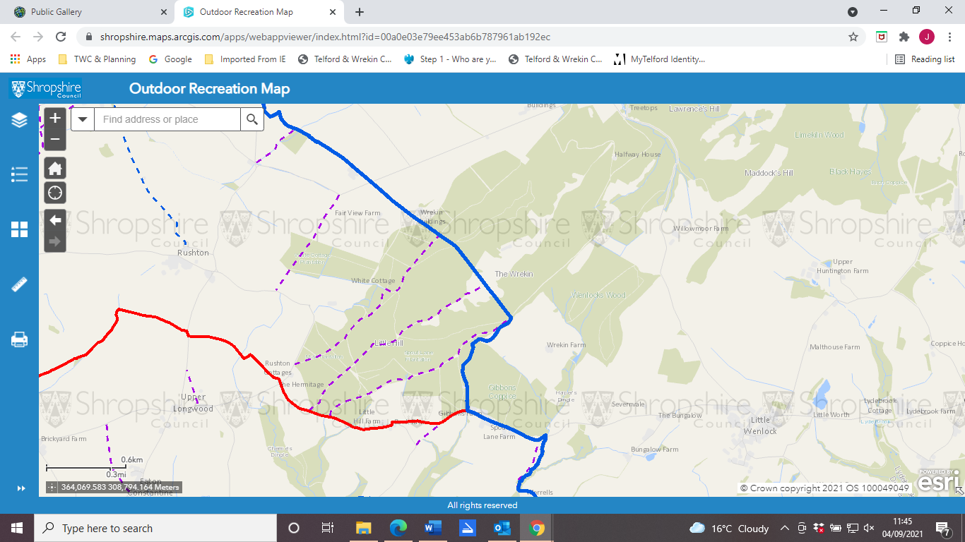

Telford paths to be upgraded.

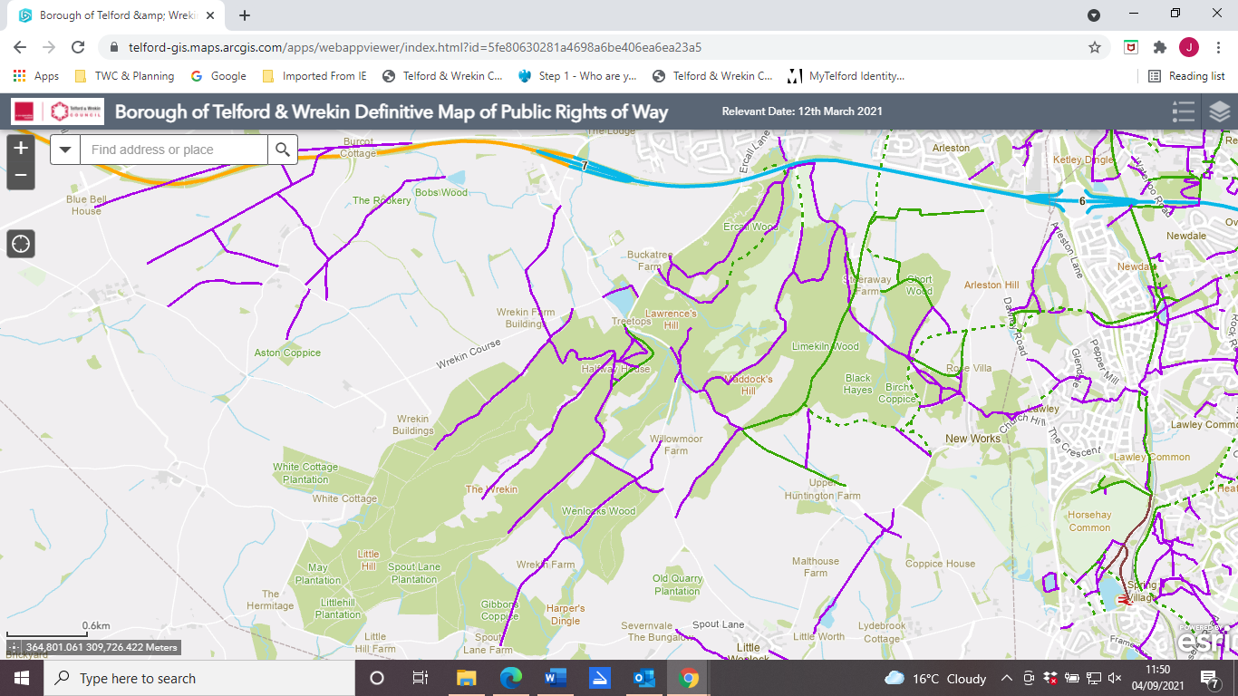

The paths to be upgraded to Bridleways straggle the Shropshire/Telford boundary line. They are the 3 that run parallel within the Wrekin Forest area. With one path in Telford joining them.

