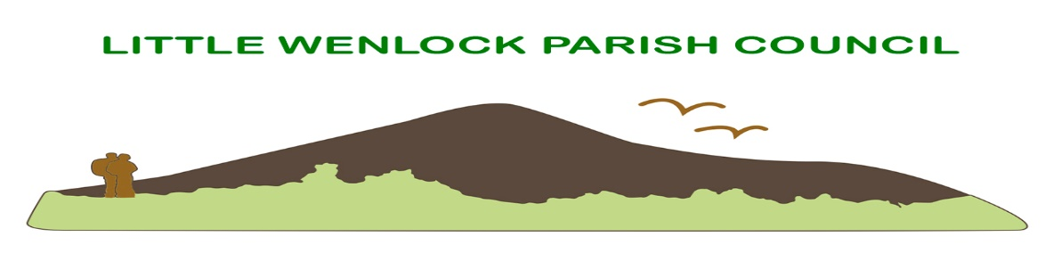

Annual Parish Open Meeting

This is a meeting open to all residents and is not a Parish Council meeting.

Date: Monday 22nd April 2024 Time: 7.00pm
Venue: Large Hall at the Village Hall

Come along and meet your parish councillors and enjoy some refreshments.

Agenda

- Opening remarks by the Chairman
- Introduction to Parish Councillors
- Borough Councillor Gareth Thomas
- Chairman’s Annual Report
- Parish Accounts for 2023/2024
- Question Time: Questions from the floor to the Parish Council.
- Closing remarks

Jayne Madeley BA Clerk

Phone: 01746 785175 Email: clerk@littlewenlock-pc.co.uk

Playing Fields
We are very fortunate in Little Wenlock to have the benefit of the playing fields, Childrens play equipment, adult gym and Tennis court. The Parish council welcomes ideas from parishioners that wish to make use of these facilities, possibly for Yoga or fitness classes for example, all enquiries to our Clerk.

Chair’s Annual Report.
One year as chair and it has been a busy year for myself and my fellow councillors for which I would like to give you all an update.
Planning
We have over the last 12 months had to consider some large-scale proposals, unfortunately against the wishes of residents through to planning inspectors the two Solar farms, New Works and Steeraway have now gained approval. We are currently trying to oppose the proposed BESS site at Jiggers bank. Alongside these schemes we have also had to consider/comment on the proposed new local plan, this plan involves circa 440 new homes within the parish. Given the scale of this proposal we arranged an open evening for residents to be given an overview by T&W planners, this enabled us to carry out a survey on the night which has given us a very clear direction based upon residents’ feedback, we will continue to keep you updated as the local plan develops.
Speed indicator device (SID)
I am pleased to advise that SID is having a positive impact on reducing speeds within the village, the monthly data is posted on the Parish Council website for residents’ review, we are in 2024 having an upgrade to SID that will see a solar panel added, this should ensure 24/7 operation and minimize the need for battery changes.
Playing Field
Management and funding of the playing field now resides with the Parish Council, we have to date installed new signage and commissioned works by external suppliers to carry out repairs to the playing field equipment, soft pour tarmac areas, barn roof and Tennis court fencing, I am grateful for the help of the working group in particular, John, Howard and George.
Parish council
We have instigated and continue to work on several areas to improve how the Parish Council operates. Parish Council meetings have now moved onto a digital medium and utilize the projector and screen in the village hall, thanks to Roy and the Village Hall for facilitating this, this allows residents to see all of the information being discussed at Parish Council meetings and reduces the need for unnecessary paperwork. We are now set up with Scribe accounting to track, monitor and generate all Parish Council financial transactions. We are currently transitioning all emails to a Microsoft industry standard solution, this will allow file sharing between councillors, again reducing the need for duplication of emails, and paperwork, thanks to Dave Owen. We will also be looking to move our website to a new platform and incorporate information previously contained in the existing information pack that has historically been handed to new residents.
We continue to chase up decisions on the One-way system and parking at the foot of the Wrekin.
Finally huge thanks to my fellow councillors, Louise, Pauline, Dave, Tamara, and our Clerk Jayne
Regards
Dave
Chair LWPC

