Parish Clerk:
Mrs Jayne Madeley BA FILCM
Cherry Oaks Farm
74 Lower Monkhall
Monkhopton
Bridgnorth
Shropshire WV16 6XF
Email: clerklwpc@gmail.com
01746 785175
CHAIRMAN:
Cllr. John Marcham
Atalaya, The Alley,
Little Wenlock,
TELFORD, TF6 5BG
Tel: 01952 505734

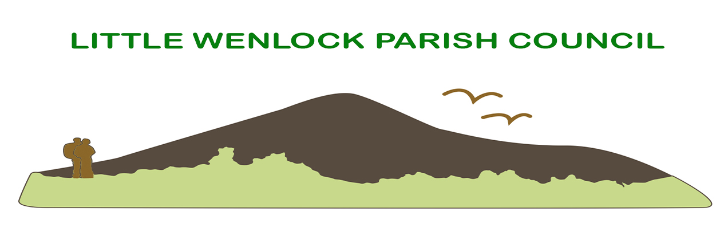

Planning Pre application discussions protocol
Introduction
In the advent of Localism and the Big Society developers are encouraged to enter into pre-application discussions with the planning authority, relevant stakeholders and the community prior to the submission of a formal planning application.
This protocol sets out how the Parish Council shall consider planning pre-application discussions not only to respect the interest of the developer but also to preserve and enhance the interests of its residents. It details how the Parish Council’s views shall be communicated to the planning authority (Shropshire Council), stakeholders, developers and the community.

Parish Council’s Involvement in pre applications
As a statutory consultee in the planning process it is essential for Little Wenlock Parish Council to be involved in the pre application process for the following reasons:

- It has a good understanding of its area and the community.
- It is keen to ensure growth within the Parish is of the right type in the right location.
- It provides an advocacy role for its residents, effectively representing their views when they feel they are unable to.
- The Parish Council is likely to be a party to future Community Infrastructure Ley and s106 negotiations on community assets required for the Parish.

Types of pre-application discussions.

The Parish Council will deal with the various types of pre-application discussions in the following way:

- The developer has entered into a formal pre-application process with the Planning Authority (Telford and Wrekin Council) and paid a fee for the service. The Parish Council will deal with such plans in the same way as a planning application.
- The developer contacts the Parish Council directly to obtain the view of the Parish Council as a corporate body. This will be done by way of a presentation to the whole Parish Council at a normal parish council meeting.
- The developer contacts the Parish Council directly to seek the informal opinion of individual councillors. The Councillor will not express a view that could be thought of as the view of the Corporate Parish Council and will report to the next available meeting that they have been approached and their response will be recorded. Councillors will on this occasion state they would prefer the view to be that of the Corporate Parish Council.

Confidentiality
The Parish Council understands there may be sometimes a need for developers to seek confidential discussions with the Parish Council. The Parish Council is mindful of its duties under the Freedom of Information Act 2000 and the need to ensure that as much information is available to the public as possible.

As a general rule all pre applications will be considered by the Parish Council in the public domain however there the following occasions will be the exception:

- The Local Planning Authority (Telford and Wrekin Council) having processed the pre application is satisfied that the application meets the provisions of the Public Interest Test and should remain confidential, with that decision made known to the Parish Council. The Parish Council will be guided by the LPA.
- The developer has provided a compelling argument that the application is commercially sensitive and disclosure of information would either prejudice or adversely affect future contract negotiations/transaction.

No other reasons will be considered to exclude members of the public and press thus rendering the documents relating to the application confidential.

Reviewed 12.5.19

