Parish Clerk:
Mrs Jayne Madeley BA FSLCC
Cherry Oaks Farm
74 Lower Monkhall
Monkhopton
Bridgnorth
Shropshire WV16 6XF
Email: clerk#
Telephone: 01746 785175

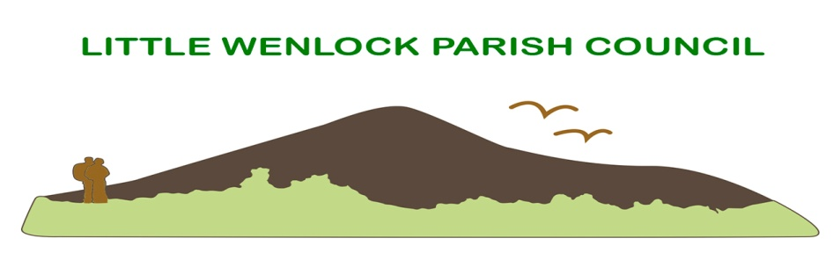

Procedure for the co-option of a new Parish Councillor as a result of a casual vacancy adopted as at 12.3.2018 date

- In the event of a resignation or any other reason for the creation of a vacancy on the Little Wenlock Parish Council the clerk will notify Telford and Wrekin Council and complete the appropriate forms for displaying on parish notice boards and Website.

2. Legislation requires that such forms are to be displayed for a period of 14 working days, the start/end dates will be logged by the clerk of the Parish.

If at the end of this period, a candidate(s) with the support of ten other parishioners has come forward the rules of election will apply.

In the event of candidates forwarding themselves to the clerk without the required support ALL candidates will considered/voted on by the full remaining Parish Council or Quorum. Parishioners thought to be suitable and qualify may be approached by the remaining Parish Councillors and offered the chance to put themselves forward.

3. The Parish Council must, as soon as practicable after the expiry of the period of 14 days, co-opt a person to fill the vacancy.

4. If the vacancy occurs within six months of the retirement of the council but a quorum is maintained, the vacancy may be left open until the next ordinary election.

5. Successful candidates for co-option onto the council must attend the next ordinary meeting where they will receive a full agenda, Code of Conduct, Standing Orders and Financial Regulations of the council. They will at this time sign their declaration of acceptance of office.

6. The register of interest will be filled in within 28 days and a copy passed to the monitoring officer at Telford and Wrekin Council.

7. The parish will be informed of the co-option via the parish notice boards, newsletter, website and the minutes of the meeting where the co option took place.

