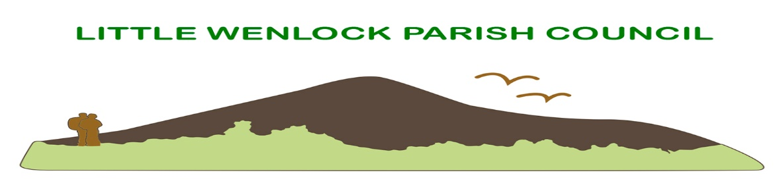
Clerk: Mrs Jayne Madeley BA 01746 785175 email: clerk@littlewenlock-pc.co.uk.
Website www.littlewenlock-pc.co.uk

Little Wenlock PARISH COUNCIL

COMPLAINTS PROCEDURE

- The following procedure will be adopted for dealing with complaints about the Council’s administration or its procedures. Complaints about a policy decision made by the Council will be referred back to the Council, or relevant Committee, as appropriate, for consideration.

- This procedure does not cover complaints about the conduct of a Member of the Parish Council.

- If a complaint about procedures, administration or the actions of any of the Council’s employees is notified orally to a Councillor, or to the Clerk to the Council, a written record of the complaint will be made, noting the name and contact details of the complainant and the nature of the complaint.

- The complainant will be asked to put the complaint in writing (letter/e-mail/standard form) to the Clerk to the Council using the address above. The complaint will be dealt with within 31 days of receipt. Refusal to put the complaint in writing does not necessarily mean that the complaint cannot be investigated, but it is easier to deal with if it is in writing.

- If the complainant prefers not to put the complaint to the Clerk to the Council (because the matter relates to the Clerk, for example,) he or she should be advised to write to the Chair.

- (a) On receipt of a written complaint, the Clerk to the Council (except where the complainant is about his or her own actions) or Chair of Council (if the complaint relates to the Clerk), will seek to settle the complaint directly with the complainant. This will not be done without first notifying any person complained about and giving him or her an opportunity to comment. Efforts should be made to resolve the complaint at this stage.

(b) Where the Clerk to the Council or a Councillor receives a written complaint about the Clerk’s actions, he or she shall refer the complaint to the Chair of Council. The Clerk to the Council will be formally advised of the matter and given an opportunity to comment.

- The Clerk to the Council (or Chair) will report any complaint disposed of by direct action with the complainant to the next meeting of the Council.

- The Clerk to the Council (or Chair) will report any complaint that has not been resolved to the next meeting of the Council. The Clerk will notify the complainant of the date on which the complaint will be considered and the complainant will be offered an opportunity to explain the complaint to the Council orally.

- Matters relating to Grievance or Disciplinary proceedings that are taking, or are likely to take place, should be dealt with in accordance with the Council’s grievance and disciplinary procedures.

- The Council may consider whether the circumstances of any complaint warrant the matter being discussed in the absence of the press and public, but any decision on the complaint will be announced at the Council meeting in public.

- The Council may consider in the circumstances of any particular complaint whether to make any without liability payment or provide other reasonable benefit to any person who has suffered loss as a result of the Council’s maladministration. Any payment may only be authorised by the Council after obtaining legal advice and advice from the Council’s auditor on the propriety of such a payment.

- As soon as possible after the decision has been made (and in any event not later than 10 days after the meeting) the complainant will be notified in writing of the decision and any action to be taken.

- The Council may defer dealing with any complaint if it is of the opinion that issues arise on which further advice is necessary. The advice will be considered and the complaint dealt with at the next meeting after the advice has been received.

Adopted July 2022
Next review May 2023

